Nanaimo, British Columbia, Canada
February 1975
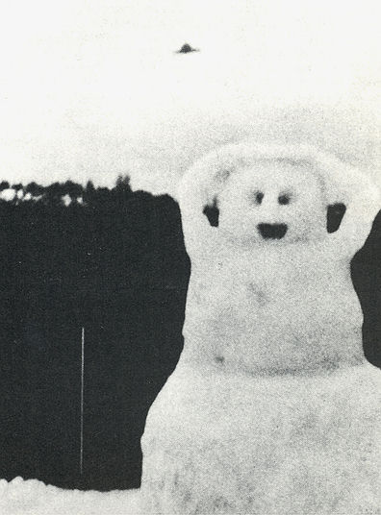
description:
This photograph in 1975 by Lance Willet of Nanaimo, BC, Canada, is one of a number in which a UFO was caught by accident while the photographer was concentrating on an everyday subject.
Source: UFO: The Complete Sightings, Peter Brookesmith
Original source webpage / article

