Nagoya City, Japan
October 4, 1975
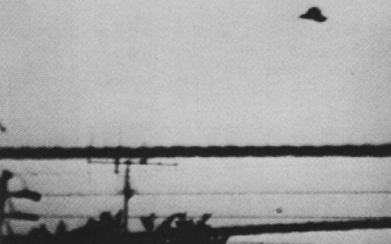
description:
Source:
Original source webpage / article

