NAVIGATION MENU Photo 176 of 176 | FIRST | PREVIOUS

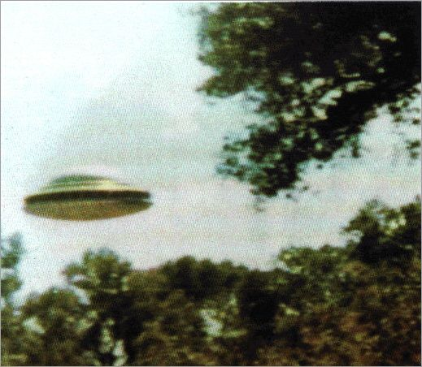
description:
Source:
Original source webpage / article

