NAVIGATION MENU Photo 172 of 176 | FIRST | PREVIOUS | NEXT | LAST

Pacific Northwest, US
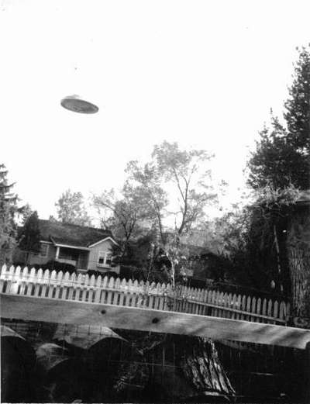
description:
Pacific Northwest, US.
Anonymous
"Thought you shuld all know about this. It's a UFO."
(El Disco)
Source: El Disco
Original source webpage / article

