NAVIGATION MENU Photo 175 of 176 | FIRST | PREVIOUS | NEXT | LAST

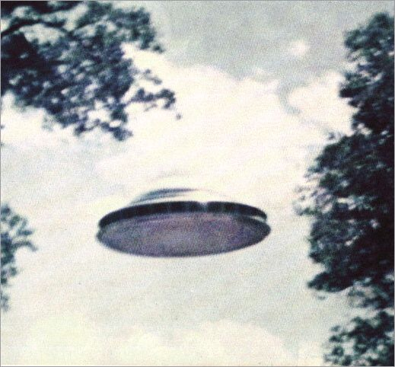
description:
Source:
Original source webpage / article

