Mt. Popocatapetl, Mexico
December 23, 2001
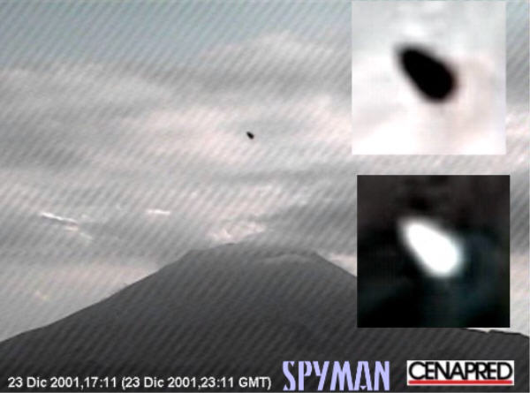
description:
Taken from a webcam that constantly monitors Mt. Popocatapetl.
Source: CENAPRED
Original source webpage / article

