NAVIGATION MENU Photo 30 of 176 | FIRST | PREVIOUS | NEXT | LAST

Mt. Popocatapetl, Mexico
December 19, 2000
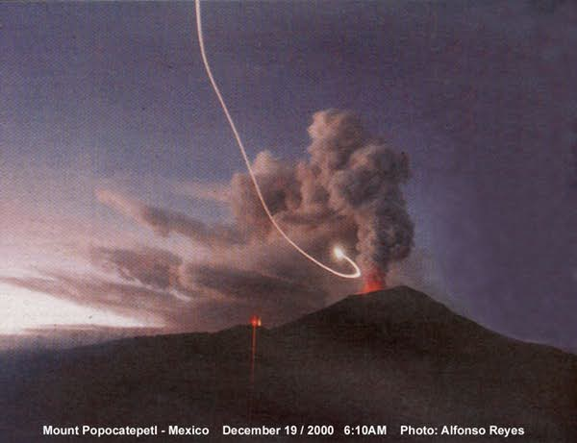
description:
The long awaited eruption of Mexico's collosal volcano Popocatepetl ( name that means " Smoking Mountain" in old nahuatl language) that took place last monday 18, brought not only fear and uncertainty but also a unexpected event captured by merely accident. Today the main headlines of local newspapers Milenio and Extramex present a photograph of an unknown luminous flying object over the erupting volcano Popocatepetl located near from Mexico City and Puebla. The spectacular photograph taken by reporter Alfonso Reyes last tuesday 19 at 6:10 AM while making a report of the gigant violent awakening present a bright luminous object that contrast with the black clouds of smoke emanated from the volcano crater. The photo was taken in a 20 seconds exposure time and a 24 mm angular lens according to Mr. Reyes testimony. However he did'nt saw actually the flying object and was until the development of the film that he discovered what the camera captured. Due to the long exposure time the camera captured the luminous descending trayectory of the object that seems to make a quick turn into the crater direction. The possibility of a meteor was discarded considering the described trayectory of the object and also no airplane or helicopter were present in that place for obvious reasons.
This is not the first time that strange unknown objects have been seen flying over this volcano. In June 29, 1999 the surveillance camera of the CENAPRED, the goverment agency for disasters prevention was monitoring Mount Popo taking pictures at time intervals. At 1:20PM the camera captured a strange disk shape dark object very near from the volcano crater and emerging among the smoke clouds. No explanation was given by the agency at the time but researchers continued gathering photographic and video evidences of continuous objects present over the smoking volcano. Certainly the photograph taken by Alfonso Reyes deserves a serious and dedicated analysis. Meanwhile this event as well as the others still remain unexplained.
Santiago Yturria Monterrey, N.L., Mexico.
Source: Santiago Yturria / Rense.com
Original source webpage / article

FAIR USE NOTICE: This page contains copyrighted material the use of which has not been specifically authorized by the copyright owner. This website distributes this material without profit to those who have expressed a prior interest in receiving the included information for research and educational purposes. We believe this constitutes a fair use of any such copyrighted material as provided for in 17 U.S.C § 107.

