NAVIGATION MENU Photo 32 of 176 | FIRST | PREVIOUS | NEXT | LAST

Mount Popocatepetl, Mexico
June 29, 1999
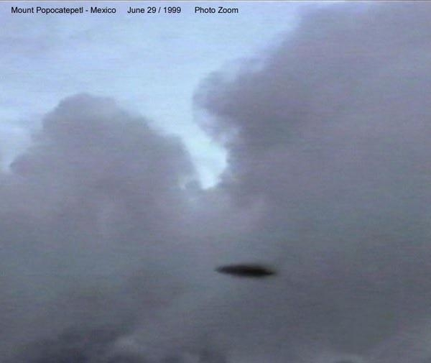
description:
Source:
Original source webpage / article

FAIR USE

