Motonau, New Zealand
October 27, 1979
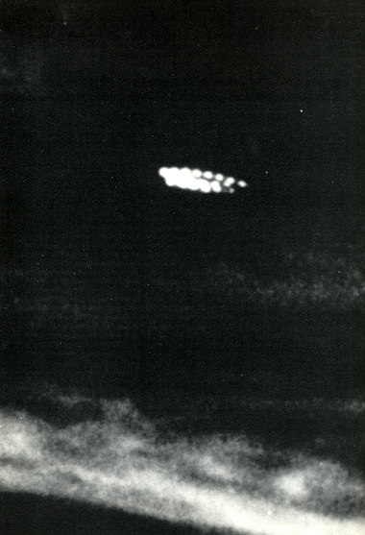
description:
Two former New Zealand Air Force photographic analysts called the picture "inscrutable". It was one of a series taken in the early morning, and only one frame on the film contained the UFO image. No one saw or heard the object in the sky at the time.
Source: UFO: The Complete Sightings, Peter Brookesmith
Original source webpage / article

