NAVIGATION MENU Photo 22 of 176 | FIRST | PREVIOUS | NEXT | LAST

75km south of Moscow, Russia
Summer, 2002
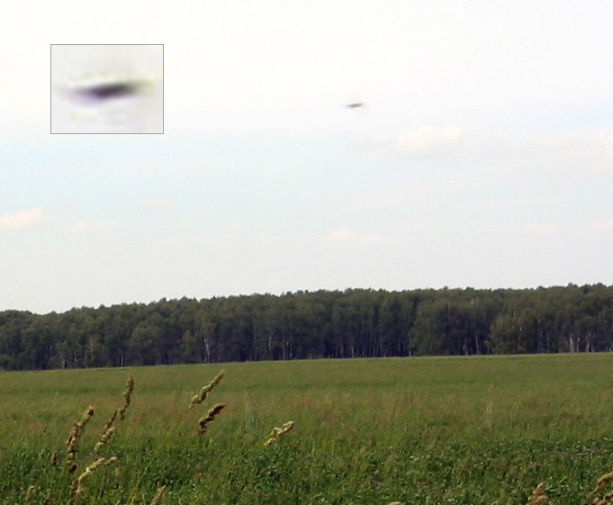
description:
Source: Submitted directly to UFOEvidence.org
Original source webpage / article

FAIR USE NOTICE

