(Mexico City?), Mexico
August 6, 1997
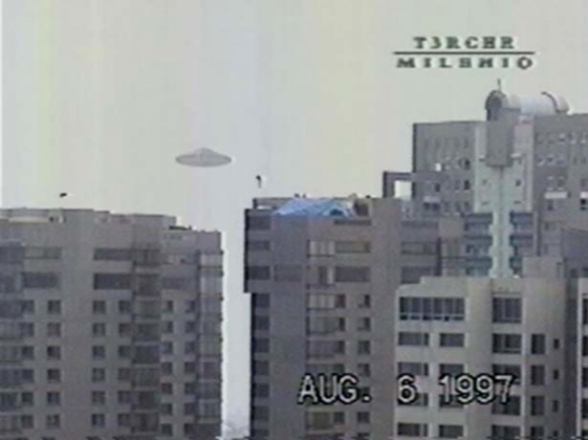
description:
Source:
Original source webpage / article

