NAVIGATION MENU Photo 29 of 176 | FIRST | PREVIOUS | NEXT | LAST

Mammoth Mountain area, California, USA
late 2000
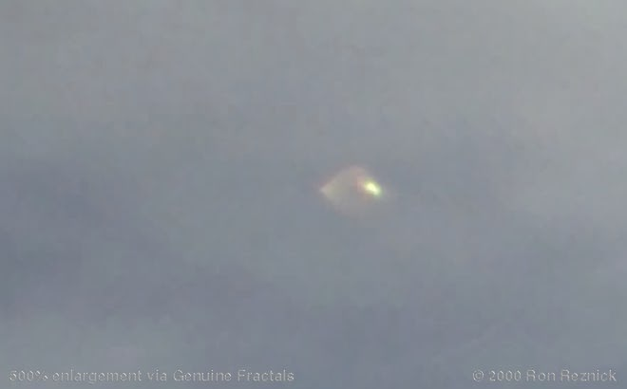
description:
Dear Jeff,
Enclosed please find three photos (one photo and two enlargements) of an unidentified (flying?) object. These were taken recently in Mammoth, CA, by Mr. Ron Reznick, a computer tech and professional photographer. To date the object has not been identified. As certain questions as to the authenticity of the photo(s) is sure to come into question, I am including a statement from Ron that he emailed to me as well as the web address where he displays his various photos. Unlike me, he has no particular interest in UFO's and such. So, while I'm happy that he got the picture...I'm also just a little bit jealous!
Sincerely, Michael Horn
-----------
Ron's letter in response to questions regarding the possibility of defects or hoax:
The camera is a Nikon D1... a very professional $5000 digital SLR. The lens is a new Nikkor 17-35mm f/2.8D AF-S EDIF in perfect condition. This is without doubt one of the world's finest wide-angle lenses and is a very expensive lens (I paid $1500 for it a few days before the trip) -- it is most certainly the best wide angle zoom lens available, and I have tested it against a 24mm f/2.8D Nikkor, which is also recognized as one of the few very exceptional wide angle prime lenses.
The quality is nearly as good as the prime. There are most certainly no defects in either the camera or the lens. The original image was shot RAW (.nef format). The unique characteristic of this format is that it is a 12-bit raw data dump from the CCD, and is only capable of being written by the D1's CCD (charge-coupled device) imager -- it cannot be written or edited by external software. The RAW format is accepted as evidence by courts, whereas any other format can be altered.
The object is in the original image, and can be easily seen when the .nef file is opened in a decoder. The only editing I did on that image was to remove some spots in the clouds caused by dust specks on the CCD that were acquired during lens changes -- this is an unavoidable problem with any interchangeable-lens camera. I was on top of that mountain to shoot scenics, and I shot a number of images from that general area.
The object shows up in none of the other images, but I did not shoot exactly that area more than that one time. I did not notice the object until I got home and started processing the images. I had no reason to add it or invent the object, and even if I did I could not alter the RAW image file if I wanted to. The original RAW .nef file is available for testing by anyone as long as my image copyright is respected.
Believe me when I say that I know enough about cameras and most certainly enough about lenses that if something like this showed up in my images I would notice right away.
I have shot well in excess of 30,000 pictures in the last 9 months. I am a fairly experienced photographer...
Ron

