Mahwah, New Jersey
January 1, 1967
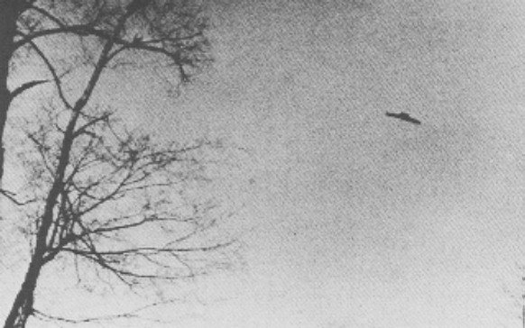
description:
Source:
Original source webpage / article

