Lunar Surface (Moon), NASA Mission Apollo 16
1972
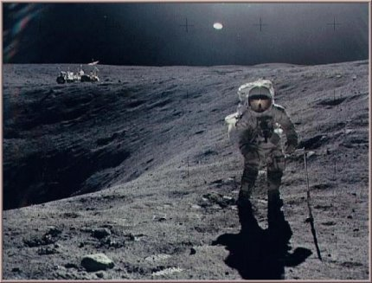
description:
Photo NASA No AS16-114-18423 - Mission Apollo 16 on the Moon.
Astronaut Charles Duke photographed collecting lunar sample at Station 1.
Source: NASA (reprinted on UFO Area)
Original source webpage / article

