Lunar Surface (Moon), NASA Apollo 16 Mission
1972
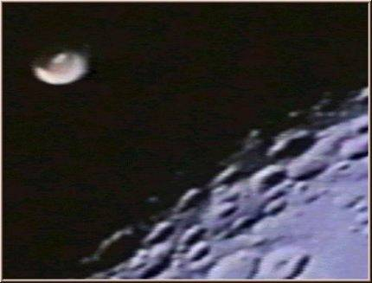
description:
Apollo 16 mission was composed by the astronauts Ken Mattingly, Charlie Duke and John W. Young, who made the video. On the film can be observed a dish like unidentified flying object while Apollo 16 approaches to the moon.
Source: NASA (reprinted on UFO Area)
Original source webpage / article

