Lunar Surface (Moon), NASA Apollo 16 photo
April 20, 1972
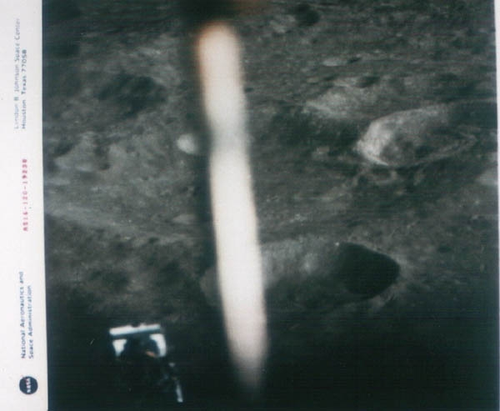
description:
April 20, 1972
Lunar Surface
NASA Apollo 16 photo
An elongated, glowing white, cigar shaped craft hovering over a crater - or simply a reflection? This photo was taken by Apollo-16 just before the April 20, 1972 landing on the Moon. Down left you see the metallic foot of the Lunar Lander. NASA photo AS16-120-19238
Source: Michael Hesemann
Original

