Los Angeles, California, USA
1991
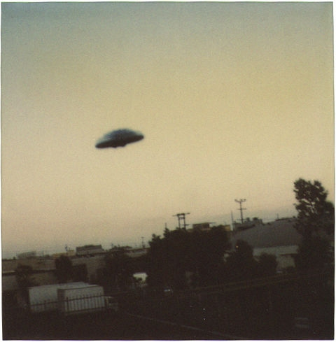
description:
Los Angeles, CA 1991
Dorothy Drudge
This was taken near LAX airport. The smog was so thick you could taste it, chew it even. I wondered if I had hallucinated, but I caught it on film, from which I'm sending you the enclosed copy print. Didn't make a sound, and was gone in a few seconds.
(El Disco)
Source: El Disco
Original source webpage / article

