Los Angeles, California, USA
February 25, 1942
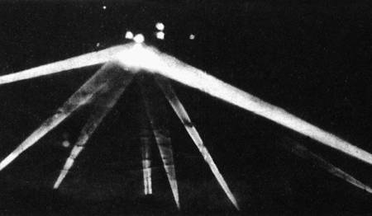
description:
Los Angeles, February 25, 1942:
THE EVENTS:
02:25pm: Alarm sirens installed in the event of a Japanese air raid are started, as flying objects are seen and announced in the sky off the city. A blackout is declared and the anxious and even terrified inhabitants follow the instructions by turning all the lights off.
03:16pm: Anti-aircraft guns open fire on the unidentified flying objects coming from the ocean, and projector beams are searching the sky. There seems that at least 2 different types of machines are flying over LA. Witnesses observe small objects flying at high altitude, of red or silver plated color, moving in formation at high speed, and untouched by the AAA salvos. Their pace is an estimated 29000 km/h. There is also a larger object which remains stationary for some time, then, when lightened by the projectors above Culver City, starts to move at a constant speed of 100 km/h in the direction of the Santa Monica cost, and later southwards in direction of Long Beach, where it goes out of sight. This large object has been touched by many AAA projectiles, according to the reports. The anti aircraft defence continues to shoot at UFOS.
04:14: There is a cease-fire, 1430 6 kilogram shells have been used. No bomb has been dropped by the unknown flying objects, and none of them could be shot down.
Source: UFOs at Close Sight (Patrick Gross)
Original source webpage / article

