Levittown, Puerto Rico
November 1980, night
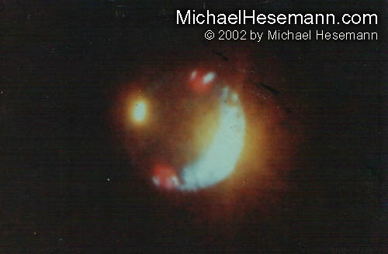
description:
November 1980, night,
Levittown, Puerto Rico
Hundreds of witnesses observed a disc, illuminated by bright lights, flying at a low altitude over a residential quarter of Levittown. When dozens of people called the local police station, a patrol car was sent. Police Officer Sgt. José Cordero arrived just in time to observe the large disc passing directly over him. He was able to take ten photos with his official Polaroid camera.
The case was investigated by Puerto Rican UFO researcher Jorge Martin. A computer analysis performed by members of German MUFON (MUFON-CES) confirmed that it must have been a large craft.
Source: Michael Hesemann
Original source webpage / article

