Kelsey Bay, Vancouver Island, (British Columbia) Canada
October 8, 1981, 11:00 AM
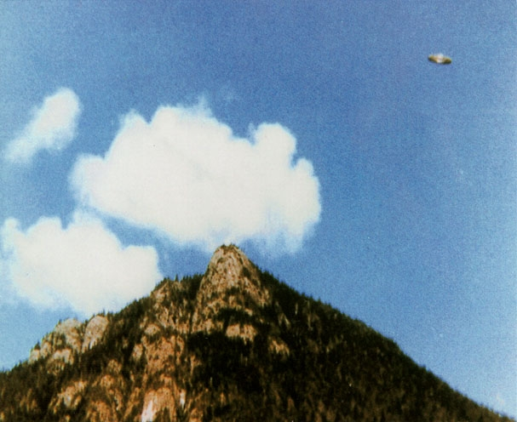
description:
UFOs at Close Sight (Patrick Gross):
The Hannah McRoberts photograph, Canada, 1981
On October 8, 1981 at abour 11:00 A.M., Hannah Mc Roberts is with her husband and their daughter on a service area close to Kelsey Bay, on the East coast of the Vancouver Island. During their pause they notice a cloud which passes on the top of a mountainous peak and makes the impression of an erupting volcano in eruption spitting a huge vaporblast. They find the scene rather amusing and worth a picture.
Several days afterwards, when the photographa are developed, they notice on one of the photograph that there is a discoidal object in the sky. Their surprise is big, as they do not remember noticing anything in the sky at the time when they shot the photograph.
They contact David Dodge, director of the of Vancouver planetarium. He examines the picture and remains disturbed by this singular photograph. He contacts a ufologist, David Powell, who analyzes the pictures and cannot find any evidence of tampering.
Richard F. Haines, a retired NASA scientist who became a famous ufologist, gets interested in the Vancouver case. He carries out a thorough analysis of the negative and cannot discover any tampering either. His analysis is inserted in the scientific report of the Sturrock Panel.
REFERENCES:
Science et Vie #976, January 1999.
Jacques Dumont, "Ovnis, un demi-siècle de recherches", Rebis editor, 2001
Analysis by Richard F. Haines on the web site of the Journal of Scientific Exploration.
Source: UFOs at Close Sight
Original source webpage / article

