Vancouver Island, British Columbia, Canada
October 8, 1981
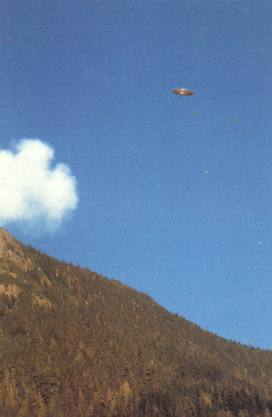
description:
Hannah McRoberts Photo
THE VANCOUVER ISLAND PHOTOGRAPH
by Gordon Creighton

