Karagol near Izmir, Turkey
Beginning of 1998
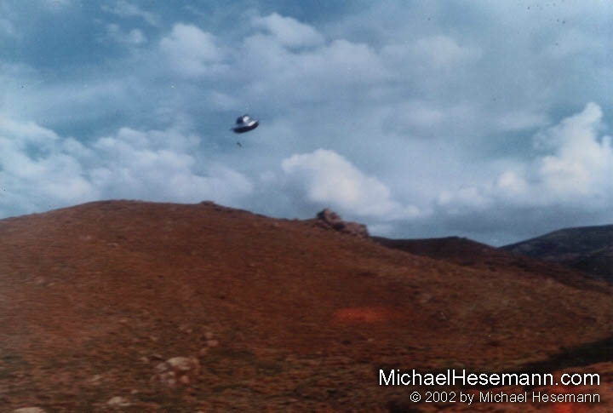
description:
Beginning of 1998
Karagol near Izmir, Turkey
"For at least a hundred times", Cem Arat and Mehmet Safak returned to the site at the Yamanlar Mountain Peak near Karagol, where they saw and photographed a strange object in February 1996. This time, one of them was called up by the Army, so they decided to go a last time as a kind of "Farewell party". And this time another UFO showed up! They shot a lot of pictures, but the object was moving so fast, that they caught it on only two.
After their military service, in the beginning of the year 2000, they contacted a local TV channel and told their story. Their photos were examined by an expert of the Aegaean University of Izmir, Dr. Ahmet Imancer, head of the Photography and Graphic Dept. He stated that he was convinced they were not a hoax and estimated the diameter of the object to be about 20 metres (60 feet), its distance about 500 metres (500 yards).
The Turkish UFO research center SIRIUS requested another analysis by the "On Photography House" in Istanbul, which, on June 16, 2000, stated: "As a result of our analysis of the 35 mm negative film, we concluded that the images on the negatives are genuine and there is no indication of a hoax on the photos delivered from these negatives. The negatives and the photographs were examined by computer and no modifications were found on them."
Thanks to Haktan Akdogan for the pictures and to Esen Sekerkarar for her detailed report on the case!
Source: Michael Hesemann
Original source webpage / article

FAIR USE NOTICE: This page contains copyrighted material the use of which has not been specifically authorized by the copyright owner. This website distributes this material without profit to those who have expressed a prior interest in receiving the included information for research and educational purposes. We believe this constitutes a fair use of any such copyrighted material as provided for in 17 U.S.C § 107.

