Huaylas Valley, near Yungay, Peru
March 1967
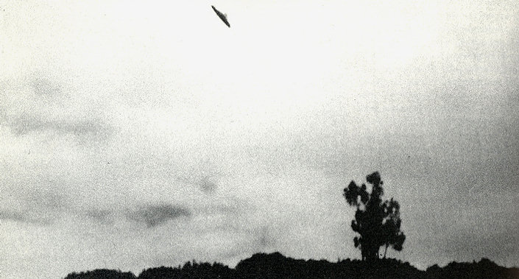
description:
One of a series of photos taken in the Huaylas Valley, near Yungay, Peru, by Augusto Arrando, on a hiking expedition in the mountains some 10,000ft (3050m) above sea level. J. Richard Greenwell made strenuous attempts to locate Arrando, but failed to meet the man in person. Hope of authenticating the photos probably vanished forever when Yungay and most of its 20,000 inhabitants were buried by a gigantic avalanche in May 1970.
Source: UFO: The Complete Sightings, Peter Brookesmith
Original source webpage / article

