Holloman Air Force Base, New Mexico, USA
October 16, 1957
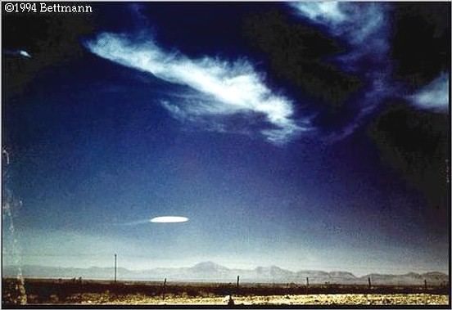
description:
Ella Louise Fortune, who worked as a nurse at the Mescalero Indian Reservation near Three Rivers, New Mexico, took this picture while driving along Highway 54 at about 1:30 PM on 16 October 1957. The UFO was hovering motionless over Holloman Air Force Base.
Source:

