Hokkaido, Japan
April 3, 1974
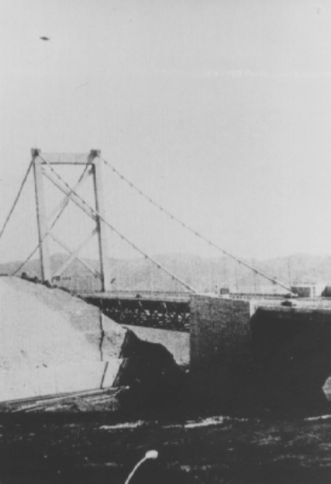
description:
Source:
Original source webpage / article

