Hokkaido, Japan
November 12, 1974
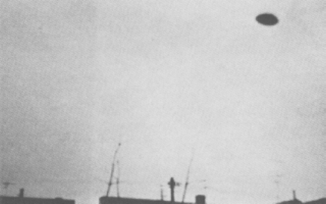
description:
At 12:00pm on November 12, 1974, eleven year old twin brothers, Yoshitsugu and Katsuji Iino, were looking at the sky from a back window of their home in Obihiro City when they noticed a mysterious dark disc-like flying object hovering in the sky. One of them went for a camera while the other kept his eyes on the object, and they succeeded in snapping four color photographs before the object rose into the clouds and disappeared from view.
Source:

