Hoboken, New Jersey, USA
9 May 1984, 8.15 p.m.
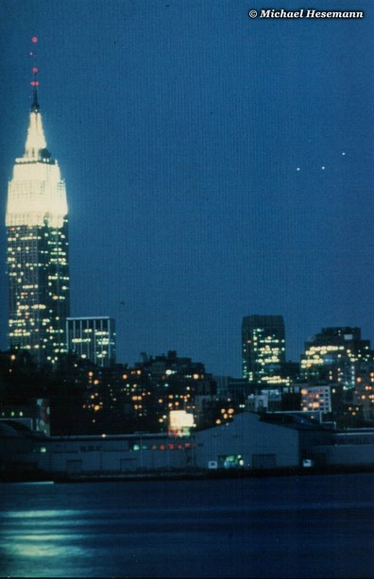
description:
9 May 1984, 8.15 p.m.,
Hoboken/New Jersey:
After I heard of the interesting UFO encounters over New Jersey in July 2001, I remembered this interesting photo. It was taken by Felippe Orego from Hoboken, New Jersey, showing a triangular UFO (or three UFOs in a V-formation) over the skyline of Manhattan. Orego sent it to my late friend and teacher Col. Colman VonKeviczky (ICUFON), who passed away three years ago and will always be remembered as one of the great pioneers of the international UFO research. He investigated the case and classified the picture as genuine.
Source: Michael Hesemann
Original source webpage / article

