Hinterschmidrüti, Switzerland
August 20, 2001, ca. 3.50 PM
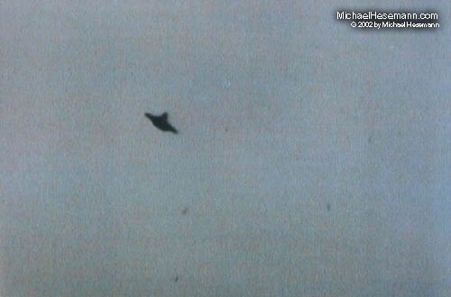
description:
August 20, 2001, ca. 3.50 PM,
Hinterschmidrüti, Switzerland
A new eyewitness photo seems to confirm the controversial Billy Meier case (see file on this website). An anonymous visitor from a nearby village took this clear photo of a domed disc with his digital camera (through a powerful telephoto lens) after his visit to Meier's “Semjase Silver Star Center”.
Source: Michael Hesemann
Original source webpage / article

