Hawaii, USA
April 25, 1974
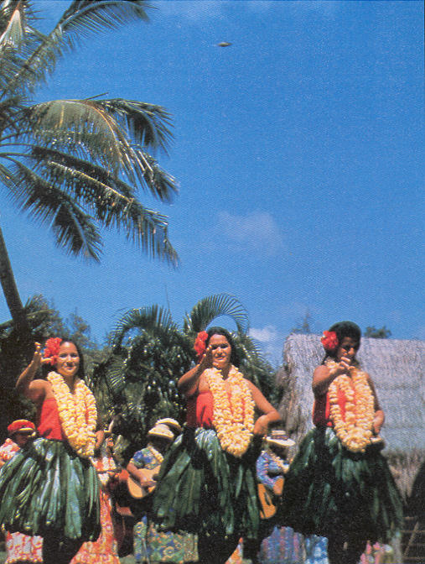
description:
A UFO photographed by chance by Tsutomu Nakayama in Hawaii. Other photographs of the scene do not show the object, and Mr. Nakayama himself was unaware of it in the sky when he took the shot.
Source: UFO: The Complete Sightings, Peter Brookesmith
Original

