Hamilton, Ontario, Canada
March 18, 1975
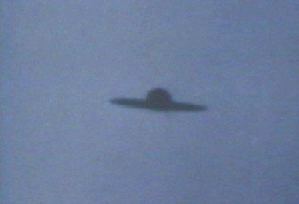
description:
An anonymous witness near Hamilton--on Lake Ontario, photographed this object which resembles a huge Mexican hat called a sombrero. This UFO may be of the same type that was witnessed hovering above Centeno, Argentina two years later.
Source:
Original source webpage / article

