Hamburg, Germany
March 7, 1977
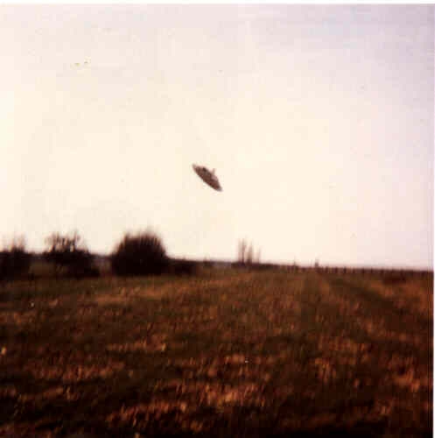
description:
UFOs at Close Sight (Patrick Gross):
Hoax UFO photograph, Hamburg Germany March 7, 1977:
THE ACCOUNT:
This picture has allegedly been captured on March 3, 1977, at about 14:00, near the river Wedel in the Hamburg area, Germany.
The standard caption offered by the several web site who present the image says:
"Herr Walter Schilling observed and photographed this flying disc with a curious rotating, fluorescent periscope-like mast. The object was very close to the ground and was tilted at an angle as it cast a 30 feet shadow on the grass to its right."
Because the close up indicates at least some resemblance to the famous Paul Trent photographs in McMinville, 1950, this resemblance with the McMinville photograph is sometimes quoted as reason to believe the picture is a hoax or on the contrary that it is not a hoax.
Actually, Michael Heseman, a highly controversial german character who published UFO litterature "as journalist, not ufologist," admitted in his book "The mystery of the Unidentified Flying Objects", 1998) that Walter Schilling had sent him a good dozens "primitive Fotocollagen" in 1981 and 1983. In June 1982 Heseman had already learned Ground Saucers Watch's opinion that the photograph show a small model. It was not easy to contact Schilling in 1984, because he was in a psychiatric hospital following legal charges for sexual misbehaviour, however, it seems that on August 11, 1983, he met with Michael Heseman and told him that the photograph show a small model he built and photographed, adding that it was "a very good joke, my friend."
REFERENCES:
The above picture was published in "Der Stand der UFO-Forschung," (The Current State of UFO Research) by I.V. Ludwiger.
The original of the picture seems to be archived at the MUFON-CES in Germany.
The photograph is not very broadly known. It appears on a 1993 CD-ROM entitled "UFO." This is were the standard caption comes from.
Source: UFOs at Close Sight (Patrick Gross)
Original source webpage / article

