Greifswald, Germany
August 14, 1990, ca. 8.35-9.03 pm
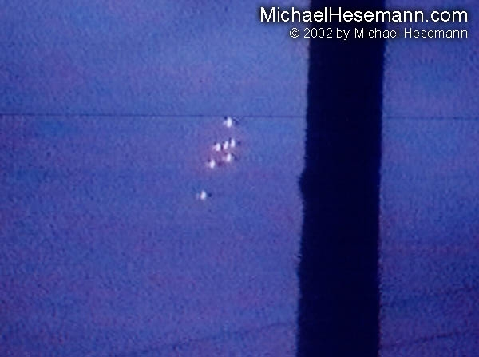
description:
August 14, 1990, ca. 8.35-9.03 pm
Greifswald, Germany,
Just six weeks before Germany´s reunification, thousands of eyewitnesses observed a formation of seven luminous objects, hovering for nearly 30 minutes over the Baltic Sea near Peenemünde, the former Nazi V-2 rocket construction site and near the Nuclear Power Plant Greifswald. Among the eyewitnesses were Russian nuclear physicist working for this installation. German UFO researchers were able to collect five amateur videos of event, which enabled them to reconstruct the position of the formation by triangulation. Sceptics were quick in refusing this interesting case as simple signal flares fired in the sky by the Russian or Polish Navy - but they ignore the fact that the formation was, without any doubt, hovering over German seas, west of the Polish border. Any military maneuver so shortly before the German reunification would have been considered an aggression and caused major diplomatic protests. But in fact both, the Russian and Polish Navies, both denied any maneuver at the time in question. On this site, we present three interesting stills from the three best videos, taken by the Russian Nuclear Physicist Dr. Ludmilla Ivanova from Greifswald, Bernhard Gröchel from Ücheritz-Bansin on Usedom and Jürgen Luchterhand, east of Greifswald.
Source: Michael Hesemann
Ori

