Gould's Hill, Dorset, England
December 21, 1993
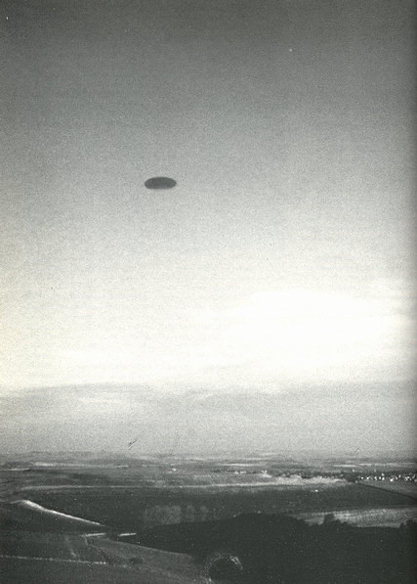
description:
An "unknown aerial phenomenon" photographed by Rod Dickinson as it flew over Gould's Hill, Dorset.
Source: UFO: The Complete Sightings, Peter Brookesmith
Original s

