UFO Photographs Slideshow

NAVIGATION MENU Photo 8 of 176 | FIRST | PREVIOUS | NEXT | LAST

Goodwood, West Sussex, United Kingdom
September 5, 2003
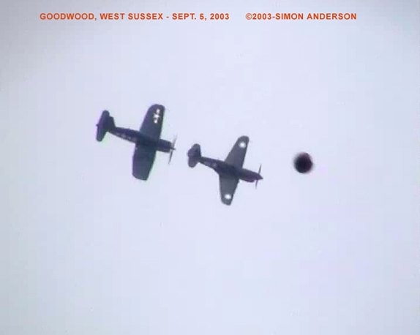
description:
Santiago Yturria
9-17-3
Two weeks ago the excitement and the traditional display of the vintage aircraft revival festival that attracts a lot of tourists and fans year by year in the UK was interrupted by the intrusion of a non anounced flying object that caused confusion and uncertainty in a dangerous situation that could have ended in a tragedy.
The incident took place in Goodwood, West Sussex on September 5, 2003 at the annual Goodwood Festival and Revival where an old aircraft display was presented. Goodwood is located just outside Chichester in West Sussex south of England, 60 miles from London and about 30 miles from Brighton and Southampton. Goodwood is also known by it's worldwide famous racing cars festival, an event that brings together hundreds of enthusiastic fans in a major event that includes new and old racing cars, motorcycles and airplane exhibitions.
Among the fans of the old war aircraft display was Mr. Simon Anderson who likes to attend and film aircraft displays and in this ocasion destiny was keeping for him an unusual and intruiging surprise.
SIMON : " I made a discovery in the sky when filming the Goodwood festival and old aircraft display.
Just two old aircraft were flying; facing north-south when filming.
A fast object shot past the aircraft I was very amazed then trying to keep filming as it went up into the clouds.
Then it went off to the south towards Portsmouth. I am interested in aircraft filming them for years at displays but never seen this thing before. "
Simon, a 29 years old from West Sussex was filming the event with a JVC Hi-8 PAL camcorder . The time was 1:35 PM and the sky was clear. After several days Simon contacted me asking for advice and sent me a VHS copy of the footage.
I must say that I got impressed by the images and the unique moment when two airplanes confronted a disc shape object in a maneuver that may have resulted in a dangerous risk of collision.
The quality of the footage is crystal clear with zooms to both the aircrafts and the UFO. The first images present two old war airplanes, one british and one american flying in formation and making a turn from left to right. Simon kept filming the airplanes and a few seconds later a strange unknown brownish object, round in shape appeared in the scene passing by from right to left close to the airplanes at certain moderated speed.
The images are clear and the unknown object was caught in several frames by Simon's camera. At this moment he realized that a mysterious object was present in the sky so he turned his camera looking for the object trying to locate it's position and in a few more seconds he found the strange intruder still in the sky. Then Simon made a great zoom to the object and it's shape and size was clearly revealed.
A disc shaped flying object was there floating making balancing movements and shining with the sun suggesting a metallic structure. This part of the footage sequence is impressive and the excitement of an impressed Simon is evident when he discovered the true shape of the unknown intruder.
Almost immediately while taping some questions began wondering in Simon's mind : What is this ? From where ? After some seconds of balancing maneuvers in wich the UFO seemed to be still in that point it began to move itself to the right making a movement aside it's right changing it's color to a certain brown tone but keeping the disc shape while showing it's outline.
Some additional movements were made and Simon decided to make a zoom out to establish height and distance from the ground for reference. A tree is visible then and the UFO at great distance like a dark point revealing Simon's videocamera potential. Then the UFO dissapeared quickly but Simon continued filming another airplane that arrived to the scene maybe in the hope that the spectacular UFO may return but it did not. Simon was certain that he captured a unique moment in history.
I made some interviews to Simon and assured him that this was indeed a UFO, a classic flying disc even that he has not know anything about UFOs before this could be the answer to his impressive experience. As this was a massive event involving many people I asked him some necesary questions for the research and Simon kindly gave me his cooperation.
SIMON: " The air space was closed at the time of the display. Many witnesses that's correct.
Persons which noticed object suggested telling a paper they fly back to usa today with a still photo from an old camera not that clear as crowds in view.People had cars with family's visiting from the usa i don't personally know the americans they just said good by as they left the area.
More people at the time pointed it out a man named Ted about 45 in age from this area said look look up in the sky near the old aircraft.
Santiago, I still have many question i need to know about this. "
Simon Anderson's experience is certainly quite unique and represent an important case for Ufology. But this incident is not the only one of it's kind that has happened. In Mexico during the Independence day some witnesses taped UFOs during the military aircraft parade in 1991, 1992 and 1993. Also in Argentina, Chile, Peru and Brazil some incidents involving UFOs and airplanes at displays and exhibitions have been documented on video by witnesses including some with tragic results.
This situation reveals how little we know or nothing about these presences that defy our knowledge challenging our airspace control in the most surprising and intruiging appearances that leave us confused and puzzled.
The Goodwood festival was now the one in turn and for those enthusiastic fans that attended this magnificent event we could only think that in some way maybe they received an extra attraction not included in the program but as a bonus, a spectacular and amazing one.
September 18, 2003
Santiago Yturria.
Comment
Pat Hair
9-24-03
The airplanes in question are an American made Curtis P-40E or F model which appears with Chinese markings used in China and Burma. The bigger-winged aircraft is an American Marine F4U-Corsair also used in the Pacific Theatre against the Japanese. Just so you know. I wouldn't want someone to doubt the UFO story because the airplanes were inaccurately described as an American P-47 Thunderbolt and a British Spitfire.
Pat Hair
Source: Santiago Yturria
Original source webpage / article

FAIR USE NOTICE: This page contains copyrighted material the use of which has not been specifically authorized by the copyright owner. This website distributes this material without profit to those who have expressed a prior interest in receiving the included information for research and educational purposes. We believe this constitutes a fair use of any such copyrighted material as provided for in 17 U.S.C § 107.

