NAVIGATION MENU Photo 31 of 176
FIRST | PREVIOUS | NEXT | LAST

Geosynchronous Orbiting Satellite, Space
November 21, 1999
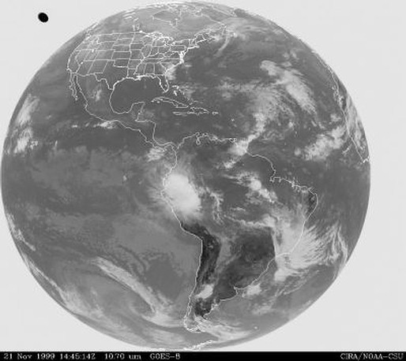
description:
The National Oceanic and Atmospheric (NOAA) has several Geosynchronous Orbiting Satellites in orbit watching the Earths weather and environment. On November 21, 1999 at 14:45 hours, one of the satellites caught an amazing photo of a UFO at an estimated hundred miles above the Earth off the state of Washington.
One of the satellites is designed to detect water vapour or clouds from space and when its camera was zoomed in, it was apparent that the craft was giving off vapour. The possibility of a computer error causing the image was completely ruled out . The UFO was present for several minutes and was a structure which radiated heat in the infrared spectrum. It was obviously very large. Similar photos were taken on June 8 , 1995 over South America.
Source: UFO Casebook
Original source webpage / article

FAIR USE NOTICE: This page contains copyrighted material the use of which has not been specifically authorized by the copyright owner. This website distributes this material without profit to those who have expressed a prior interest in receiving the included information for research and educational purposes. We believe this constitutes a fair use of any such copyrighted material as provided for in 17 U.S.C § 107.

