UFO Photographs home | UFO Evidence home
UFO Photographs Slideshow

NAVIGATION MENU Photo 13 of 176 | FIRST | PREVIOUS | NEXT | LAST

Flying from Los Angeles to Singapore
December 13, 2003
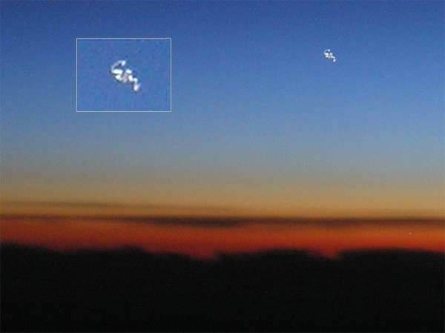
description:
From the witness who took the photograph:
"I shot this picture on December 13 2003 around 35 thousand feet when I was flying from Los Angeles to Singapore.
I saw a small orange dot far away which did not blink but had an orange and red glow to it. But it did not look like a planet.
So I took a picture of it and when I downloaded the picture to my computer and zoomed in, I was surprised to see that it was some flying object that I was not able to identify."
Source:
Original source webpage / article

FAIR USE NOTICE: This page contains copyrighted material the use of which has not been specifically authorized by the copyright owner. This website distributes this material without profit to those who have expressed a prior interest in receiving the included information for research and educational purposes. We believe this constitutes a fair use of any such copyrighted material as provided for in 17 U.S.C § 107.

