Floridad, Uruguay
July 11, 1971, 3.30 PM
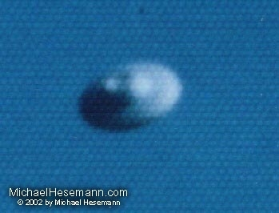
description:
July 11, 1971, 3.30 PM
Floridad, Uruguay
When Hector Rufino Delgado saw a strange, disc-shaped craft approaching him, flying on its side, he grabbed his camera - and shot a series of six pictures when the object changed its position and passed him and disappeared in the opposite direction. Please compare the enlargement with the Turkish UFO photos we show in the next two month! (Courtesy: Wendelle C. Stevens)
Source: Michael Hesemann
Original source webpage / article

