Europe
1940's
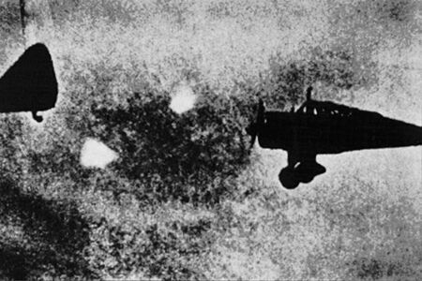
description:
UFOs at Close Sight (Patrick Gross)
Foo Fighters photographs are very rare. Two of them are seen here following Lysanders aircraft of the RAF during World War II in Europe.
Although reports of sightings, which were eventually termed "UFOs," can be traced far back into history, students of the subject have arbitrarily placed the beginning of the modern era in the mid-1940s with the appearance of UFOs over both the European and Pacific Theaters of War. These UFOs were called by many names, all of which revealed a lack of understanding of their nature and source. To the Allies, they were "kraut fireballs" or "foo fighters," with the latter term surviving. It is believed that the Germans and Japanese saw them also.
Reports of "unexplained transparent, metallic and glowing balls" began in quantity in June, 1944, at about the same time the Allies invaded France, and Nazi Germany began launching V-1 flying bombs aimed at London, thus starting the era of unmanned missiles. Reports intensified in November 1944, not long after the first German V-2 ballistic rockets were fired at London and Paris.
Pilots and their air crews reported that the "odd things" flew in formation with their airplanes, "played tag" with them, and generally behaved as if they were under intelligent control. At no time were they said to have displayed aggressive behavior. Nevertheless, most people assumed they were an experimental enemy device being prepared for operational use. Rumors of highly advanced weapons were common at this time, fed by the awesome reality of the V1 and V2 weapons. The following are typical of the scores of "foo fighter" reports on record. Rumors persist that the U.S. Eighth Air Force in England commissioned a study on these reports, but no documentary evidence has yet been found.
Source: UFOs at Close Sight (Patrick Gross)
Original source webpage / article

