NAVIGATION MENU Photo 20 of 176 | FIRST | PREVIOUS | NEXT | LAST

Eastern United States
September 11, 2002
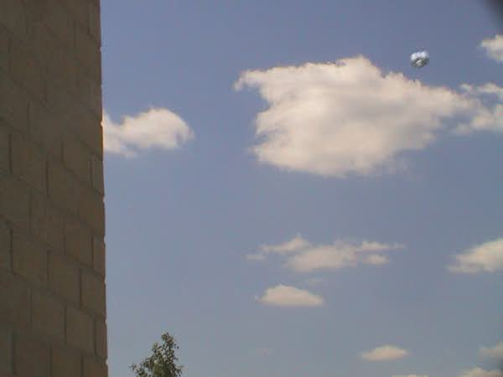
description:
The following photos were submitted with detailed information from the photographer, who choses to remain anonymous to the general public. The photos were taken in the Eastern US. There are no signs whatsoever of digital manipulation or tampering. Note the similarities of this object with some of the Anthony Woods UFO photos from Bedhampton, England. Note: Images have been down-sized and compressed due to extreme load on the server. This leaves behind some jpeg compression artifacts not present in the originals we received. See the enlargements from the originals which show no pixelation.
____
I work in a relatively urban area, and I walked outside today (Sept 11th 2002) to shoot some stills of clouds around the parking lot, for a website. I used a digital 8 camcorder, with smartcard for still pictures. I shot on the first shot, something pretty damned odd, but I didnt see it in the camera first, I saw it after the first shot. I then followed what appeared to be a *very* silver chromed object for about 30-40 seconds. I got only stills, despite it being shot on a digital 8 cam. I had just got done filming my son's black belt testing in Tae Kwon Do, and had removed the tape...go figure, when I could *really* use it. I relied on the smart media card to get as many as possible. I have 6.
The object darted about with unbelieveable speed, stopped, darted, stopped, etc. I at first glance, believed it to be a mylar balloon, until it stopped and remained still, then shot to the left away from me, then towards me and down, and eventually off to my right. I truly tried to remain calm and collected, telling myself to get reference foreground objects in the shots. I got a couple, but I had to keep one eye open to see it at times. One shot shows it coming towards me and up, and altho I didnt plan to, I caught it partially behind a lightpost. Had it come any closer I would have called to the guard desk inside to see it, but just as I thought of doing so, it slid away, at a speed I dont care to calculate.
The photographer answered the following specific questions for clarity:
1. Did you notice any sound coming from the object?
No. Nothing whatsoever.
2. Were you aware of anyone else nearby watching it as well?
No, I was very alone. I debated at one point going back to the door to get someone, but I would have missed a lot of the shots you see.
3. Judging from what you saw, could the movement of the object have been by force of wind, or did it seem to have its own propulsion?
Seemed to have it's own way of getting around. It didn't follow the wind, although I thought at first it might be a group of balloons, the wind was rather gusty that day, and it never went the way it should if it was a balloon. Not to mention the speed was unreal.
4. Did it appear to rotate at all?
Not that I could tell. I was really paying more attention to where it was.
5. The object appears to be very large as it maintains clarity even at a very high altitude in the last frames. Any size guesstimate judging from your own perspective?
I wouldn't fancy even a guess. Impossible to really tell.
6. Have you encountered UFOs before?
Yes.
Source: Rense.com
Original source webpage / article

FAIR USE NOTICE: This page contains copyrighted material the use of which has not been specifically authorized by the copyright owner. This website distributes this material without profit to those who have expressed a prior interest in receiving the included information for research and educational purposes. We believe this constitutes a fair use of any such copyrighted material as provided for in 17 U.S.C § 107.

