East Germany
1982 or 1983
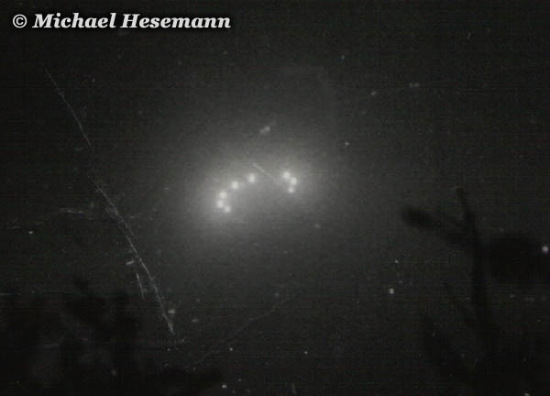
description:
UFO over East Germany:
An official NVA photo!
In early 1995, I was on a lecture tour through several cities of the eastern part of Germany, the former communist German Democratic Republic (GDR - German: DDR). After one of my lectures, in Gera/Thuringia, a former officer of the National People's Army (NVA), the armed forces of the GDR, entrusted me enclosed picture. It was taken

