Earth Orbit, GEOS-8 Satellite, Space
July 17, 1992
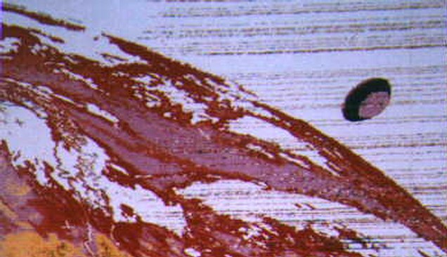
description:
CHILEAN TV STATION AIRS SATELLITE'S 400 KM UFO VIDEO:
On Tuesday, January 26, 1999, TV viewers in Chile were astonished when a Santiago station broadcasted satellite video images of disc-shaped UFOs measuring hundreds of miles in diameter.
The video images were aired by Television de la Universidad Catolica (TV-UC) on Canal (Channel) 13. The video footage was shot by Geostationary Orbital Environmental Satellite 8 (GOES-8) on two separate occasions a few years ago.
According to Chilean ufologist Luis Sanchez Perry, the program "showed an infrared photo taken by GOES-8 on July 17, 1992, clearly showing a large disc-shaped object in outer space above the Pacific Ocean in front of (just west of) the Chilean coast."
According to Mario Vilches, the gigantic saucer measured "400 kilometers (240 miles) in diameter."
The July 1992 image was captured by Servicio Aereo Fotometrico Ltda., an airmapping business in Santiago de Chile, the national capital.
"The lines that can be seen in front of the UFO belong to electromagnetic interference that came from the UFO," Sanchez explained.
THE IMAGE:
At the time the image was taken, GOES-8 was in a geostationary orbit 21,600 miles (36,000 kilometers) above Earth. The huge disc appears to be moving at the same orbital speed as the satellite, approximately 6,696 miles per hour (10,713 kilometers per hour).
"Three more images were taken at 10-minute intervals, and the UFO came through very clear," Sanchez added.
The second GOES-8 video was shot on April 7, 1996. Although the image disappeared very quickly from the GOES website, it was downloaded by Chile's Centro Meteorologico Regional de Antofagasta. This image "shows the UFO over the Atlantic in front of (just east of) the Brazilian coast."
The GOES-8 video images were discussed during the broadcast by two ufologists, Dr. Mario Dussuel of Comite de Estudios de Fenomenos Aereos Anomalos (CEFAA) and Rodrigo Cuadra of Equipe Superior de Investigacion Ovniologica (ESIO). CEFAA is Chile's official national study group, composed of government agencies, local ufologists and the Fuerza Aerea de Chile, FACH (the Chilean Air Force).
----------------------
In its evening news broadcast on January 26, 1999, Chilean broadcaster Channel 13 aired a story involving a infrared photo taken by the GOES-8 weather satellite (part of the orbiting NOA series). The image, taken July 17 1992, shows clearly a huge disc shaped object in outer space high above the Pacific Ocean in front of the Chilean coast. This image was captured by "Servicio Aero Fotometrico (SAF) de Santiago" and handed to the local authorities (Air Force). Copies of the images were also given to a few people like Mr. Gustavo Rodriguez, former ATC and UFOlogist who now works for CEFAA (Official UFO Commitee).
The original image has been colored for analysis purposes and temperature variation is 40°C between colors. The black ring shows a temperature over 50°C and in the central part about 10°C. The lines that can be seen in front of the UFO belong to electromagnetic interference that apparently eminates from the UFO. Importantly this does not represent a malfunction with this satellite, for similar photo's were taken by GOES image servers around the world and erased very quickly in the U.S.A.
In respect of the picture itself, it is said by experts in satellite image analysis that the object is real and enormous; in fact somewhere between 450 and 500 km in diameter. The UFO is moving at the same speed as the GOES-8 because at least three further frames taken automatically over the following 10 minutes depict the same object very clearly and minus blurring, as one might expect due to the timing of the GOES-8 camera. The GOES-8 is a geostationary satellite positioned some 36,000 km above the earth and travels at 3.1 km/sec.
The curious thing is that 4 years later, on April 7th1996, a similar thing happened again. Again an image was also taken by GOES-8. The UFO was now over the Atlantic in front of Brasilian coast. It was also huge in size (approx. 400km in diameter). On this occasion the images were recovered by Centro Meteorologico Regional de Antofagasta, and while I don't have any copies of this I have seen a picture. It is less impresive than the first photo' capture of1992 and represents a much darker object, showing temperatures of 40°C approximately in it's darker zone and -40°C in it's more clear parts. This reveals that it emits some sort of energy. Neither the Chilean goverment nor military have commented on the photographs at this time
I wish to thank Dr. Mario Dussuel (CEFAA consultant and E.S.I.O. collaborator), and Rodrigo Cuadra (member of E.S.I.O.) for their help gathering parts of this important information.
Luis C. Sanchez Perry
Chilean Director
Skywatch International
Source: UFOs at Close Sight
Original source webpage / article

