Devon, England
1972
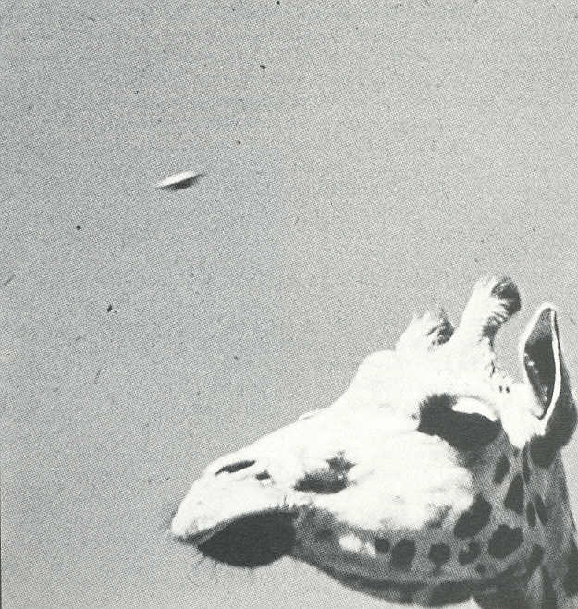
description:
An "accidental" UFO photograph, taken by Wilfred Power in 1972 at the Plymouth Zoo, Devon, England.
Source: UFO: The Complete Sightings, Peter Brookesmith
Original source webpage / article

