Denver, Colorado, USA
January 1996
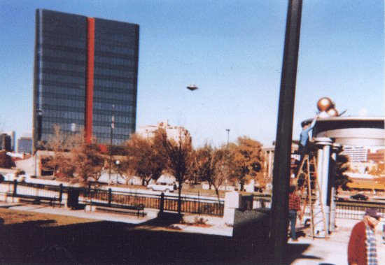
description:
This photo appeared in a recent issue of UFOCUS, but it was not in color. It was taken in Denver, Colorado, January 1996 by Joe Clower, who was photographing some workmen painting the gold balls on a city monument. He was waiting for the workmen to get ready for the photograph when he saw this strange bell-shaped flying object in the sky.
Since the camera was already in hand, he took one picture while the object was at the left of the tall building. Then the object went behind the building and came out on the right side, and Joe took this second picture of it. There are three people in the photo, one on the ladder, one at the bottom of the ladder, and one man walking past. None of them seem to be aware of the UFO.
I confess that I haven't been able to do much with this photo. I tried various computer tricks to sharpen the picture and make it clearer, and nothing seemed to improve it, so in the end I left it as it is, with no changes. The image is too small for any effective enhancement. I have included an enlarged picture at maximum scanner resolution, but it is still not very clear. It's the best I can do.
If anyone with fancy photo software wants to try to work with it, I can email high resolution scans of the original in TIF format (Caution!!! The original files are 10.6MB and 1.95MB in size!), but don't expect much more in the way of results.
Bob Thrift Institute For UFO Research Editor, UFOCUS Magazine http://www.frii.com/~iufor
Source: UFOCUS / Rense.com
Original source webpage / article

