Cumberland, Rhode Island, USA
July 3, 1967
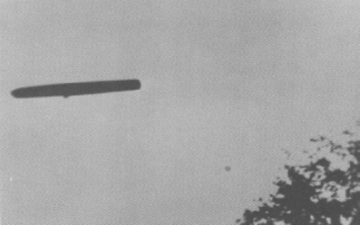
description:
Source:
Original source webpage / article

