Corsica, France
February 12, 1971
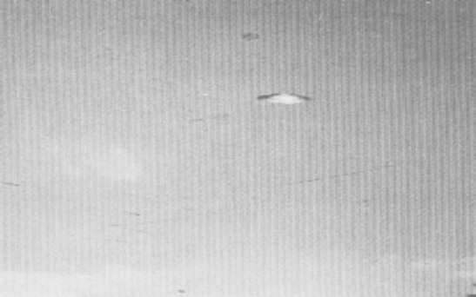
description:
Source:
Original source webpage / article

