Cordoba, Argentina
1960
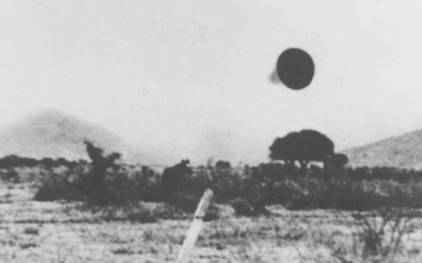
description:
Source:
Original source webpage / article

