Cluj, Romania
August 18, 1968
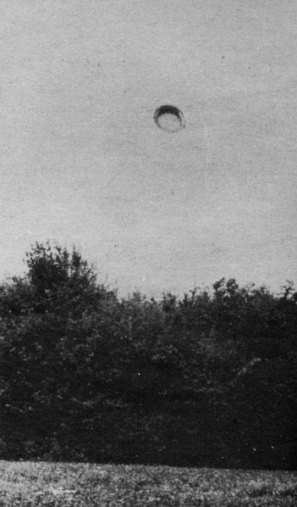
description:
The Cluj 1968 pictures, Romania:
CLUJ 1968:
One among the series of four photographs of a diurnal disc captured on photograph near Cluj in Romania by Mr. Emil Barnea on August 18, 1968.
The weather was splendid, 36°C without any wind while Barnea and his friend Miss Matea walked in the forest with a couple of friends. His friend shouted that she sees "something," and when he joined her he also saw a large round object, of metallic appearance and shining in the sun in the sky above the top of the trees. Amazed, Barnea remembered all the same that he had his camera and while the UFO advanced slowly changing direction and increasing its luminosity, then suddenly accelerating until he disappeared at the horizon, he had time to take four photographs.
According to him the object was at an altitude of approximately 600 meters considering a 85° elevation on this photography, and 30 meters in diameter.
Source: UFOs at Close Sight (Patrick Gross)
Original source webpage / article

