Chiba, Japan
May 11, 1975
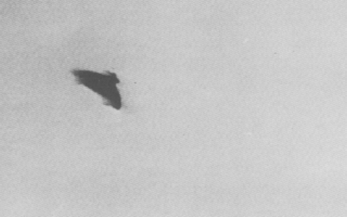
description:
At 9:00am on May 11, 1975, young Ryutaro Umehara, snapped 4 color pictures, of a featureless dark lens-shaped object flying in the sky as it descended in a falling-leaf fashion.
Source:
Original source webpage / article

