Centeno, Argentina
June 21, 1977
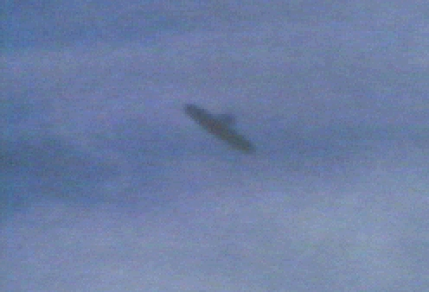
description:
Source:
Original source webpage / article

