Cave Junction, Oregon
1927
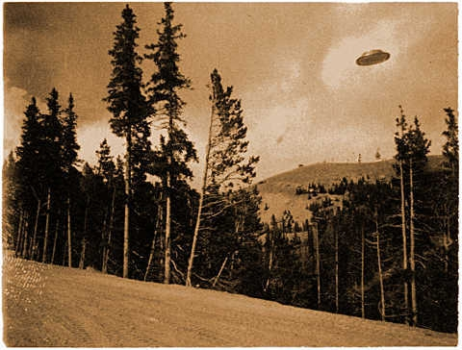
description:
Cave Junction, Oregon
The Volunteer Fireman of Cave Junction, Oregon
"Our question is: have you heard of this thing, and if so, do you have this picture or others like? I, for one, would like to remind myself and some of the guys here that I may be getting on in years, but I'm still of sound mind and body. Again, it happened around 1927 or 1926. Thank you very much. You are doing a great service."
(El Disco)
Source: El

